**DAILY ONLINE ACTIVITIES SUMMARY**

|  |  |  |  |  |  |  |  |  |
| --- | --- | --- | --- | --- | --- | --- | --- | --- |
| **Date:** | **29-05-2020** | | | | | **Name:** | **Nihal Rafiq** | |
| **Sem & Sec** | **4th A** | | | | | **USN:** | **4AL18CS052** | |
| **Online Test Summary** | | | | | | | | |
| **Subject** | | **Operating Systems** | | | | | | |
| **Max. Marks** | | **30** | | **Score** | | | **26** | |
| **Certification Course Summary** | | | | | | | | |
| **Course** | **Introducer Coding for Beginners: an HTML and CSS Online Course** | | | | | | | |
| **Certificate Provider** | | | **BitDegree** | | **Duration** | | | **60 hours** |
| **Coding Challenges** | | | | | | | | |
| **Problem Statement:**  **1: Write a java program to find size of the largest ‘+’ formed by all ones in binary matrix.**  **2. Write a C program to generate first N Armstrong numbers.** | | | | | | | | |
| **Status: Executed** | | | | | | | | |
| **Uploaded the report in Github** | | | | | **Yes** | | | |
| **If yes Repository name** | | | | | **https://github.com/nihal-art/lockdown-coding** | | | |
| **Uploaded the report in slack** | | | | | **Yes** | | | |

Online Test Details:

1. The test was from module 2 of OPERATING SYSTEM (18CS45).The time duration was 45 minutes from 09.00am to 09.45pm.There were 30 questions of MCQ type. Score I received is 26/30.

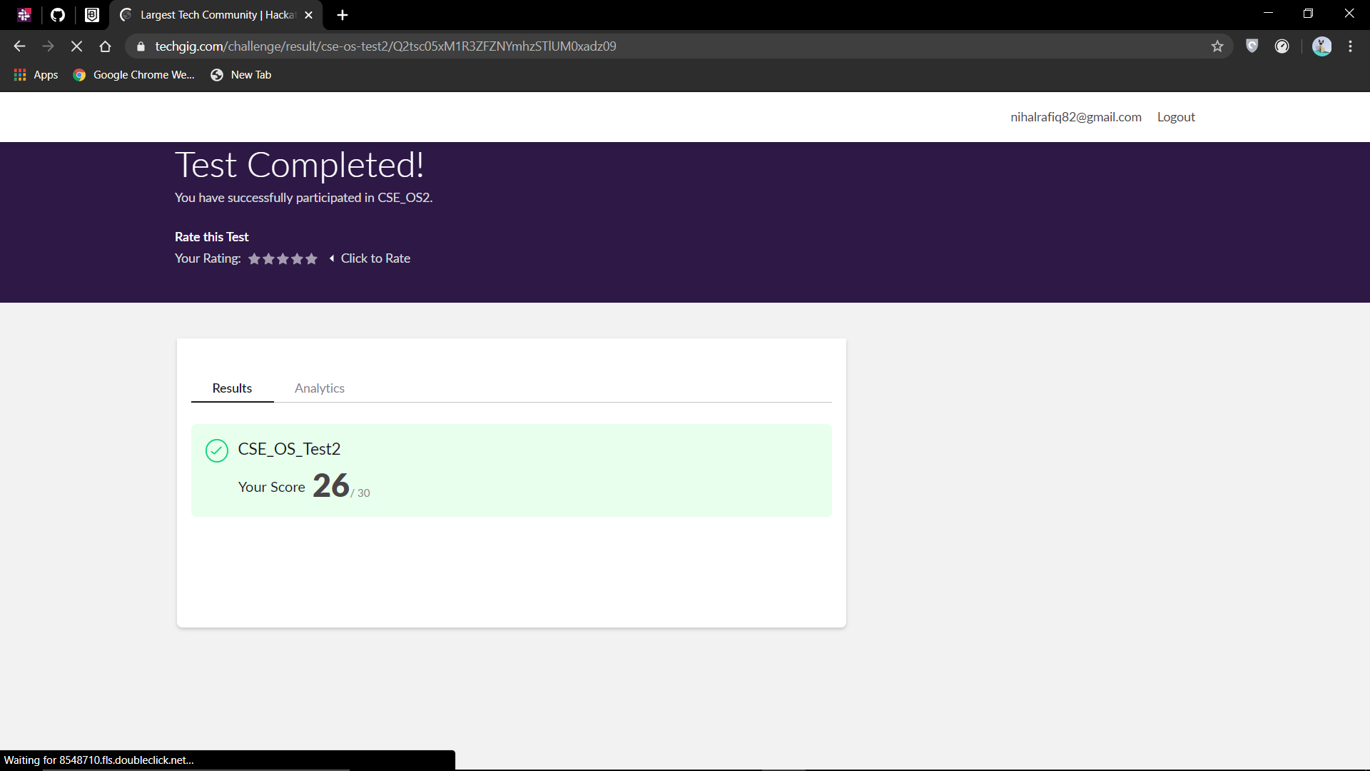

Certification Course Details:

I have opted my Online Certification Course in BitDegree. The course I have opted is Introducing Coding for Beginners: an HTML and CSS Online Course.

The course covers the following topics:

* Basic web development
* Creating forms, buttons and other elements
* HTML coding basics
* CSS basics

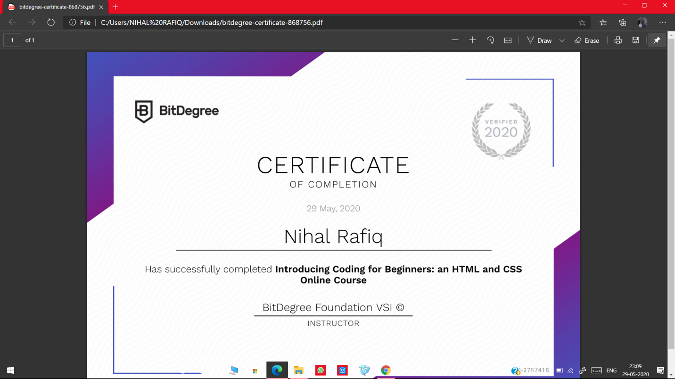

Coding Challenges Details:

**CODING CHALLENGES:**

1. Write a java program to find size of the largest '+' formed by all ones in binary matrix. Given a N X N binary matrix, find the size of the largest ‘+’ formed by all 1s.

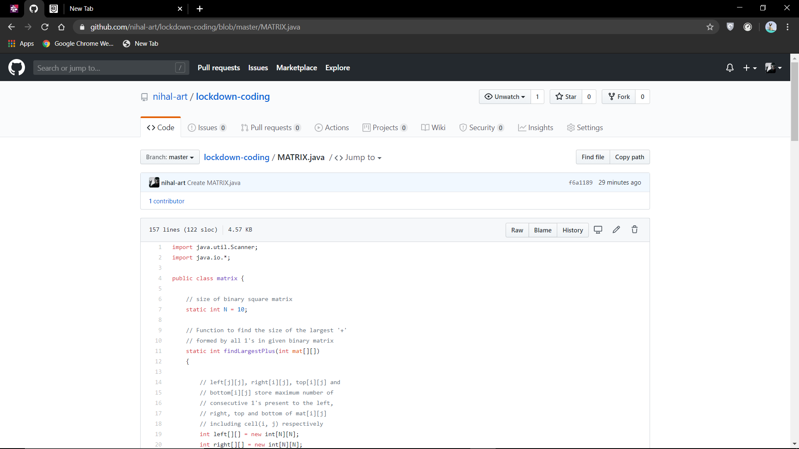

2. Write a C program to generate first N Armstrong numbers.

Armstrong number is a number that is equal to the sum of cubes of its digits. For example 0, 1, 153, 370, 371 and 407 are the Armstrong numbers.

Example 1:Let's try to understand why 153 is an Armstrong number.

153 = (111)+(555)+(333),where:(111)=1,(555)=125,(333)=27,So:1+125+27=153.

